Nama : Rizqi Surowati  
NIM : 18090072  
Kelas : 5C

1. Source Code  
   ModelUser.php 🡪 application/ model

ModelBuku.php 🡪 application/model

autoload.php 🡪 application/config

database.php 🡪 application/config

1. Database  
   a. user  
   b. role  
   c. kategori  
   d. buku
2. Capture Hasil

* user

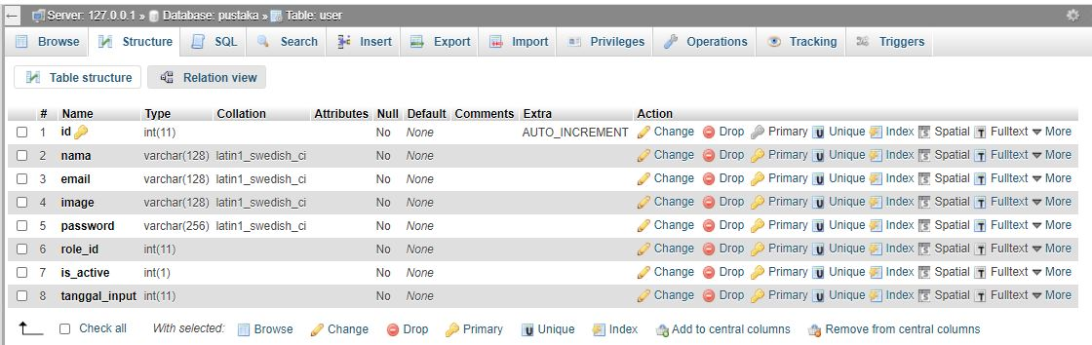

* role

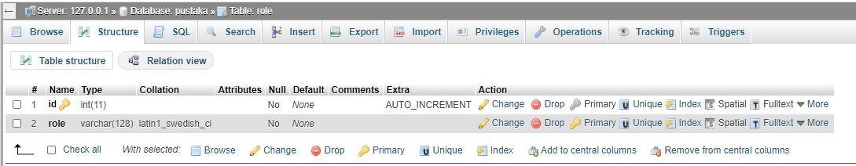

* kategori

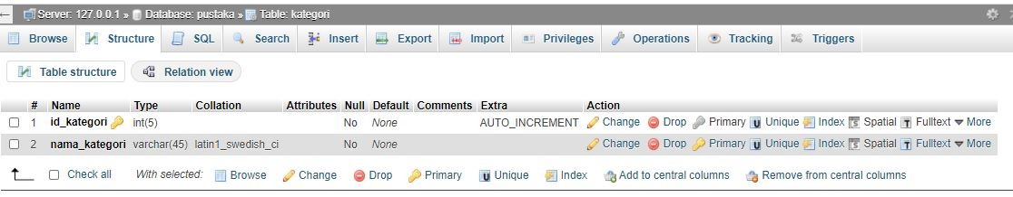

* buku

